“DineTech: Smart Ordering System”
A Project Report Submitted in the partial fulfillment of the requirements of the course titled
“Problem Solving Through Programming (JAVA)”

BACHELOR OF TECHNOLOGY
In

DEPARTMENT OF FRESHMAN ENGINEERING
By

A Bhavana Sri 2520030232
K Sai Joshna 2520030293
Ch Sahasra Gayathri 2520030306
P Teja 2520030596
K Tejas Reddy 2520080027
T Harsha Vardhan 2520080047

Under the Esteemed Guidance of

Guide Name
Designation
Department of Freshman Engineering




K L (Deemed to be) University

DEPARTMENT OF FRESHMAN ENGINEERING

Declaration

The Project Report entitled “ DineTech: Smart Ordering System ” is a record of Bonafide work of A Bhavana Sri -2520030232, K Sai Joshna -2520030293, Ch Sahasra Gayathri -2520030306, P Teja -2520030569, K Tejas -252008027 ,T Harsha Vardhan - 2520080047 submitted in partial fulfillment of the requirements of the course titled “Problem Solving Through Programming (JAVA)” under the B.Tech Ist Year Trimester - I program in Department of Freshman Engineering at K L University. The results presented in this report have not been copied from any other department, university, or institute.

A Bhavana Sri-2520030232

K Sai Joshna 2520030293

P. Teja – 2520030569

T. Harsha Vardhan – 2520080047

K. Tejas Reddy - 2520080027

CH . Sahasra Gayatri - 2520030306

K L (Deemed to be) University

DEPARTMENT OF FRESHMAN ENGINEERING

1

CERTIFICATE

This is certify that the java project based report entitled “Dine Tech - Smart ordering system” is a bonafide work done and submitted by A Bhavana Sri -2520030232, K Sai Joshna -2520030293, Ch Sahasra Gayathri -2520030306, P Teja -2520030569, K Tejas -252008027 ,T Harsha Vardhan - 2520080047 in partial fulfillment of the requirements of the course titled “Problem Solving Through Programming (JAVA)” under the B.Tech Ist Year Trimester - I program in Department of Freshman Engineering, K L (Deemed to be University), during the academic year 2025-2026.

Signature of the Guide

Signature of the Course Coordinator Signature of the HOD

ACKNOWLEDGEMENT
The success in this project would not have been possible but for the timely help and guidance rendered by many people. Our wish to express my sincere thanks to all those who has assisted us in one way or the other for the completion of my project.

Our greatest appreciation to my Course Coordinator Dr Y Ashok, and my guide RAMAKANTH KOMATI, Department of Freshman Engineering which cannot be expressed in words for his/her tremendous support, encouragement and guidance for this project.

We express our gratitude to Dr. N. Chaitanya Kumar, Head of the Department for Freshman Engineering for providing us with adequate facilities, ways and means by which we are able to complete this project-based Lab.

We thank all the members of teaching and non-teaching staff members, and also who have assisted me directly or indirectly for successful completion of this project. Finally, I sincerely thank my parents, friends and classmates for their kind help and cooperation during my work.

A. Bhavana Sri-2520030232

K. Sai Joshna 2520030293

CH . Sahasra Gayatri - 2520030306

P. Teja – 2520030569

T. Harsha Vardhan – 2520080047

K. Tejas Reddy - 2520080027

ABSTRACT:
DineTech is a smart, easy-to-use digital system built in Java that lets restaurant customers order food and pay directly from their table using an app-like interface.
It completely replaces paper menus and manual billing. After logging in with their name and table number, customers can browse the menu, add items to their digital cart, and check out the total bill. The system then provides a live tracking screen to show exactly which stage their order is in (e.g., "Being Prepared" or "Ready for Pickup").
The main goal is to make ordering faster and more accurate, reducing staff workload and improving the overall dining experience. It also automatically saves all order and login details for restaurant records.

Introduction to DineTech:
DineTech is a simple yet effective digital ordering system developed in Java using the Swing library for its graphical interface. The main purpose of this project is to replace the traditional, slow process of restaurant ordering with a fast, accurate, and completely digital experience. It focuses on improving customer service and restaurant efficiency by allowing diners to place orders, view an itemized digital bill, and track the preparation status of their food in real-time right from their table. By automating these steps, DineTech helps reduce manual errors and speeds up the entire service cycle.

Project Content Overview
The DineTech application guides the customer through five main steps:

1. Login
The customer first enters their Name, Mobile Number, and Table Number. These details are immediately saved into a secret log file for the restaurant's administrative records.

2. Menu and Ordering
Customers choose their food from a comprehensive digital menu. They select items and quantities, adding them to a digital shopping cart. The system uses a specialized data structure (a Map) to store both the menu items and the customer's current order quantities.

3. Billing and Payment
Once the order is complete, the system generates a full, itemized digital bill and calculates the final total. Customers select a payment method (like UPI or Card). Once they hit "Pay," the entire order summary, including customer details and the final bill, is saved as a detailed record file for the restaurant's administration.

4. Live Order Tracking
After payment, the customer is taken to a live screen that shows the order status. The progress of the meal, from "Placed" to "Ready for Pickup," is clearly displayed. A simulation button allows the kitchen staff (or in this case, the user) to advance the order through the different preparation stages, providing transparency.

5. Review
The final step is a simple page where the customer can provide a rating and write feedback. This completes the digital dining journey.

Conclusion
DineTech successfully demonstrates the power of Java programming to create a practical, real-world application. It effectively uses core programming concepts like loops, conditions, and data storage (Maps) combined with the Swing GUI to deliver a smooth user experience. Beyond serving the customer, a key achievement is the automatic logging of all critical data—login credentials and full bill summaries—into persistent files, which is vital for the restaurant's records and process analysis. The project ultimately achieves its goal of promoting a more efficient and customer-friendly digital transformation within the restaurant industry.

Index

S.  No. | Chapters | Topics | Page.no
 |  | Acknowledgement
 |  | Abstract
1 | Introduction | - Background of the project  - Problem statement | 1
2 | System Architecture | - High-level architecture diagram/Block diagram  - Class Diagram
3 | CO’s Attainments | - CO1 Attainment  - CO2 Attainment  - CO3 Attainment  - CO4 Attainment  - CO5 Attainment  3.6 CO6 Attainment
4 | Screen Shots | - Screen Shots
5 | Testing | - Test cases and results
6 | Future Enhancements | - Planned features  - Possible integrations or optimizations
7 | Conclusion | - Summary of the project  - What was achieved  7.3 Skills learned during development
8 | References | - Books, tutorials, documentation sites used

9 | Appendices | - Installation/setup instructions  - User manual or guide  -Geo Tag photos with guide  -Review forms with guide signatures

CHAPTER -1 INTRODUCTION

Background of the Project

The DineTech project was created to solve common problems found in traditional restaurants, which rely too much on old methods like using paper for orders and calculating bills by hand. This manual process often leads to mistakes, slow service, and leaves customers feeling frustrated because they have no idea when their food will be ready.
DineTech is a simple computer program, built using Java, designed to make the whole restaurant experience smoother and more efficient. It acts as a digital self-service system where customers enter their information and select items directly from a digital menu. This immediately eliminates errors and speeds up the ordering process. The system also calculates the final bill automatically, ensuring accurate and quick checkout.
Crucially, DineTech provides a live order tracker so customers can see exactly what stage their food is in ("Being Prepared," "Ready," etc.), adding transparency. On the management side, the system automatically saves every important detail—customer logs and full order receipts—into files, providing the restaurant with perfect digital records for accountability and business analysis. In short, DineTech is about using smart technology to upgrade the dining experience, making it faster, more reliable, and completely error-free.

1.2 Problem Statement:
Restaurants often waste time and make mistakes when taking customer orders and calculating bills by hand. This leads to slow service, confused customers, and lost records for the restaurant.
The Problem Areas:
- Errors: Waiters might write down orders incorrectly, or the kitchen might miss an item.
- Time: Billing and order tracking are slow, which means customers wait longer and the restaurant can't serve as many people.
- Records: Important customer and sales data isn't tracked or saved automatically.

CHAPTER -2 SYSTEM ARCHITECTURE

High-level architecture diagram

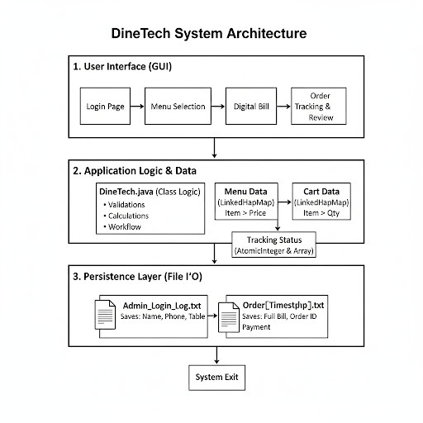

CHAPTER -3 CO’s ATTAINMENT

3.1 CO1 Attainment: Fundamental Programming Constructs

CO1 Syllabus | CO1 Concepts Included in Project
Apply fundamental programming constructs such as data types, operators, conditional and iterative statements in Java to develop logic-based solutions for basic computational problems. | Variables, data types, operators (assignment, arithmetic), conditional statements (if/else), iterative statements (for loops, for-each loops), Ternary Operator, and Lambda expressions (functional programming).

3.1.1 Scenario’s for CO1 implementation.
Scenario 1: Using variables and data types to store runtime data.
- Code Implementation: The code uses String to store customer details (username, userPhone, tableNumber) and int for calculations (finalTotal).
- Example: private int finalTotal = 0; and private String username = "";
Scenario 2: Using conditional statements for input validation and program flow.
- Code Implementation: Input validation is performed on the login page.
Scenario 3: Using iterative statements (loops) to process collections/calculate totals.
- Code Implementation: for-each loops are used to iterate over the cart to update the display and calculate the bill.

3.1.2 CO1 code screen shot.
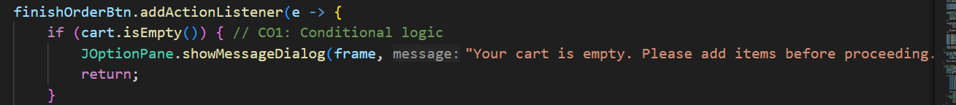
3.2 CO2 Attainment: Arrays and Algorithm Design

CO2 Syllabus | CO2 Concepts Included in Project
Design, trace, and optimize algorithms using one-dimensional and two-dimensional arrays to solve mathematical, quantitative, and real-world problems. | One-dimensional array for sequence management, basic algorithmic design.

3.2.1 Scenario’s for CO1 implementation.
Scenario 1: Using a one-dimensional array for sequence management.
- Code Implementation: The status cycle for order tracking is managed by a one-dimensional array of strings.
Scenario 2: Simple algorithm design for data processing/calculation.
- Code Implementation: The logic to calculate the total bill for the order involves accessing related data (item price) based on the order data (item quantity).
3.2.2 CO1 code screen shot.
3.3 CO3 Attainment: Advanced Problem-Solving
CO3 Syllabus | CO3 Concepts Included in Project
Construct and evaluate advanced problem-solving logic using strings, recursion, and bitwise operations for solving complex mathematical, pattern-based, and combinatorial problems. | String manipulation (splitting, substring) for data presentation and ID generation.

3.3.1 Scenario’s for CO1 implementation.
Scenario 1: String manipulation for data display.
- Code Implementation: Removing the price from the menu item string when displaying it in the cart or bill.
Scenario 2: String manipulation for dynamic ID generation.
- Code Implementation: Creating a unique, time-based Order ID using substring on the timestamp.

3.3.2 CO1 code screen shot.
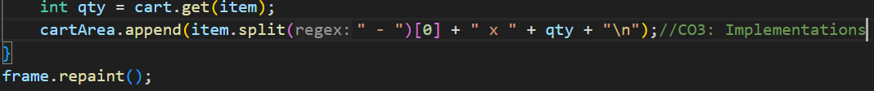
3.4 CO3 Attainment: Object-Oriented Programming (OOP)
CO4 Syllabus | CO4 Concepts Included in Project
Develop structured and modular programs by applying object-oriented programming principles such as encapsulation, abstraction, and modularization using Java classes, methods, and constructors. | Class Definition, Encapsulation (private fields), Constructor, Modularization (dedicated methods for each page/task), Method Calls.

3.4.1 Scenario’s for CO1 implementation.
Scenario 1: Class definition and Object Instantiation.
- Code Implementation: The entire system is defined within the DineTechJavaProject class, and its execution starts by creating an object.
Scenario 2: Encapsulation and Abstraction.
- Code Implementation: All core components (frame, fields, data maps, colors) are declared as private instance variables, hiding internal state from external access.
Scenario 3: Modularization using methods.
- Code Implementation: The program flow is structured through dedicated, single-purpose methods.
Scenario 4: Constructor Usage.
- Code Implementation: The DineTechJavaProject() constructor initializes the main frame and calls setup methods.
3.4.2 CO1 code screen shot.
3.5 CO5 Attainment: Extensible and Reusable Java Programs
CO5 Syllabus | CO5 Concepts Included in Project
Design extensible and reusable Java programs employing inheritance, polymorphism, abstract classes, interfaces, and reflection API to solve domain-oriented problems... Students will model real-world entities and relationships through effective OOP architecture. | Extensible API (Swing) for GUI, Object Modeling (Menu items, Orders), potential for Inheritance (base class for a complex application structure).

3.5.1 Scenario’s for CO1 implementation.
Scenario 1: Use of Extensible API.
- Code Implementation: Extensive use of the Swing library for all graphical elements.
Scenario 2: Modeling real-world entities.
- Code Implementation: The menu and cart maps model the real-world entities of dishes and a customer's order.
Scenario 3: Potential for Inheritance.
- Code Implementation: The main class serves as the foundation for a larger system where specialized components (e.g., AdminPanel extending a BasePanel) could be added later.

3.5.2 CO1 code screen shot.
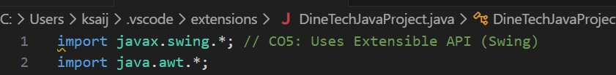

3.6 CO6 Attainment: Robust, Scalable, and Generic Java Applications
CO6 Syllabus | CO5 Concepts Included in Project
Implement robust, scalable, and generic Java applications integrating exception handling, file I/O, generics, and collections framework, along with functional programming constructs to handle real-world data-driven tasks. | Collections Framework (LinkedHashMap), File I/O (FileWriter), Exception Handling (try-catch block, throws IOException), Generics (JComboBox<String>, AtomicInteger), Concurrency (AtomicInteger), Functional Programming (Lambda expressions).

3.6.1 Scenario’s for CO1 implementation.
Scenario 1: Using the Collections Framework for data storage.
- Code Implementation: Uses LinkedHashMap to store menu items and the current cart contents, ensuring order is preserved.
Scenario 2: File I/O and Exception Handling for robustness.
- Code Implementation: The saveCredentials() and saveBillSummary() methods use FileWriter within a Try-with-resources block to ensure file resources are properly closed, handling potential IOException.
Scenario 3: Concurrency and Generics.
- Code Implementation: Uses AtomicInteger to manage the shared state of the order status index, which is safe in a multi-threaded environment (good practice for scalable applications).
Scenario 4: Functional Programming (Lambda Expressions).
- Code Implementation: Uses lambda expressions for concise implementation of ActionListener for GUI buttons.

3.6.2 CO1 code screen shot.
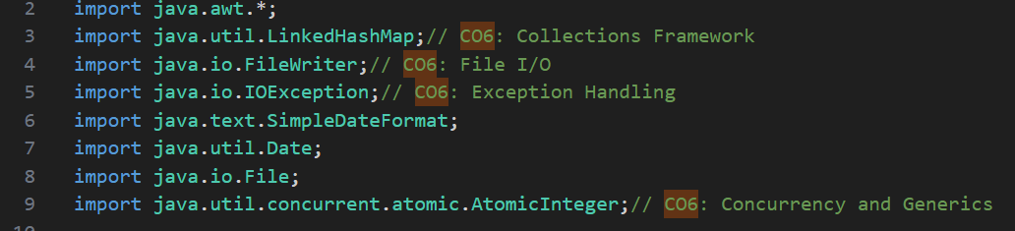

CHAPTER -4 SCREENSHOTS

4.1 Screen Shots

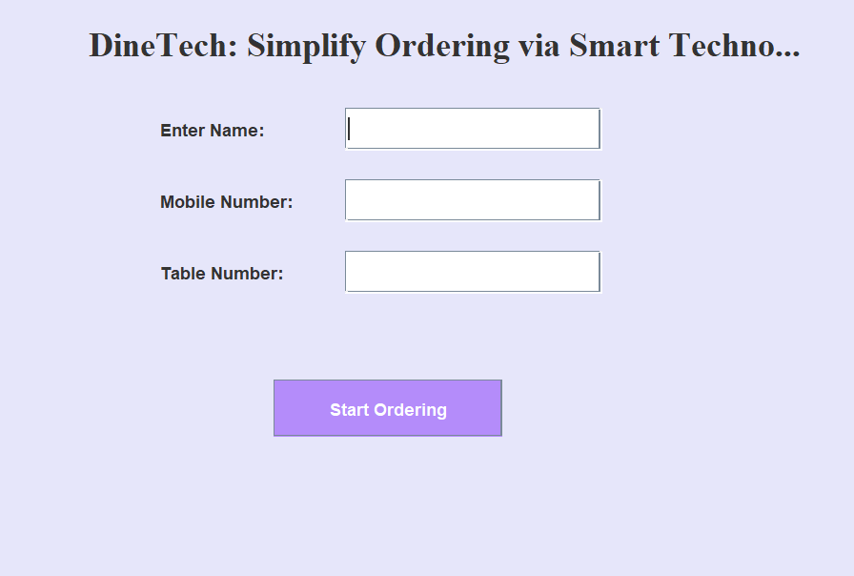

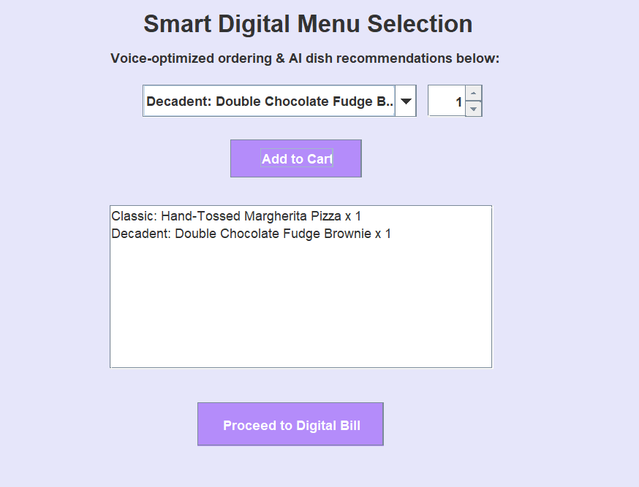
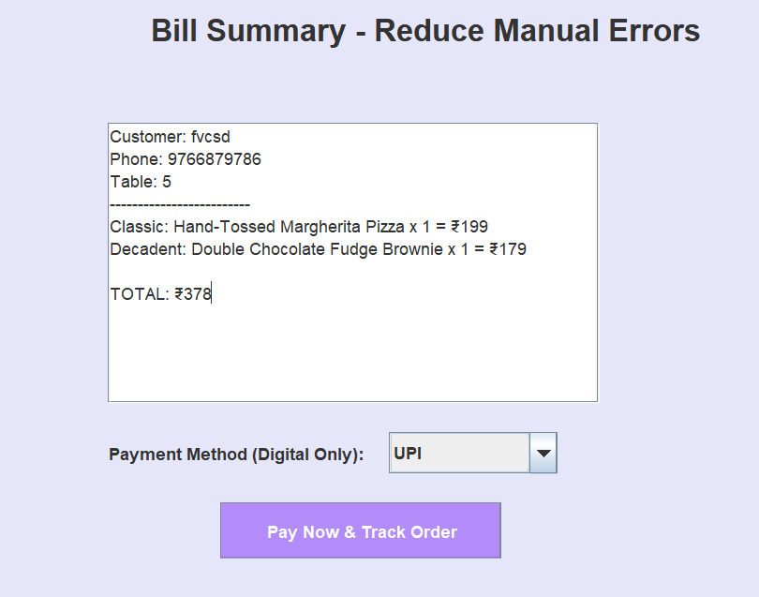

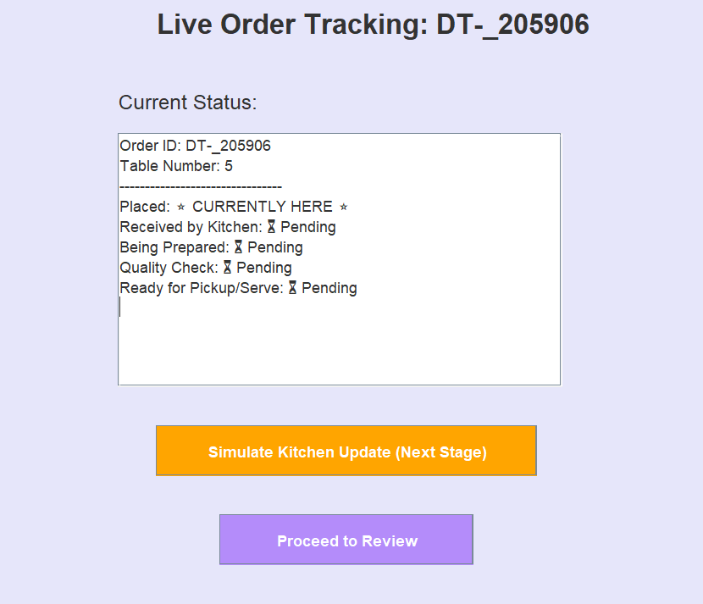

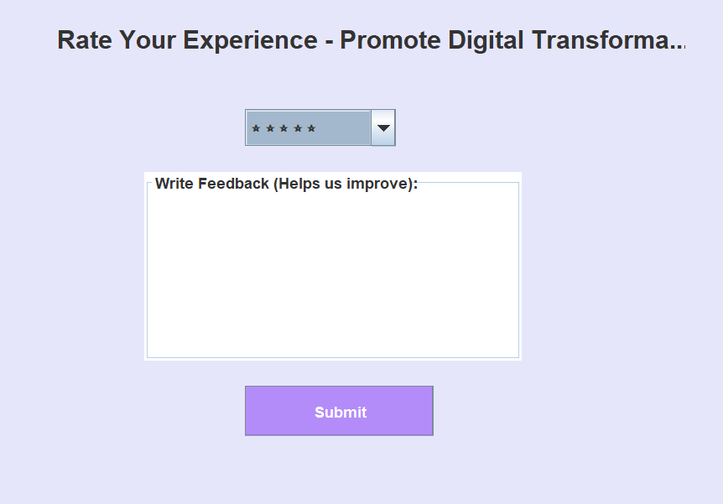

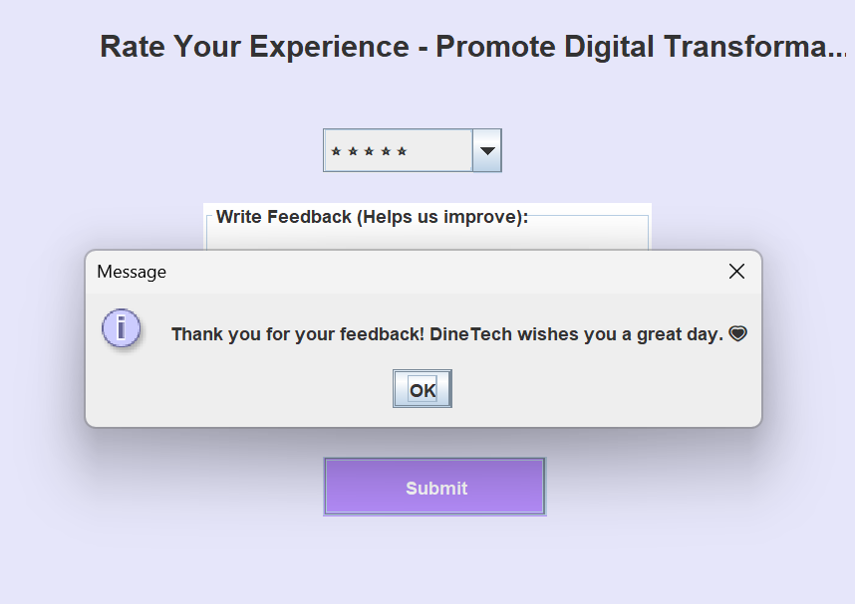

CHAPTER -5 TESTING

Test Cases and Results

I. Login and Input Validation (loginPage, saveCredentials)
Test Case ID | Feature Tested | Input/Steps | Expected Result
L02 | Mandatory Logging Check | Follow steps in L01. | A new, time-stamped entry is appended to the Admin_Login_Log.txt file.
L03 | Empty Field Validation | Leave Name blank. Fill Phone and Table. Click "Start Ordering". | An Error Dialog appears: "Please enter all details correctly!". Stays on Login Page.
L04 | Phone Length Validation | Phone: "12345" (less than 10 digits). Fill Name and Table. | An Error Dialog appears: "Please enter all details correctly!". Stays on Login Page.

II. Menu Selection and Cart Logic (menuPage)
Test Case ID | Feature Tested | Input/Steps | Expected Result
M01 | Item Addition | Select "Crispy Zucchini Fries," Qty: 2. Click "Add to Cart". | Cart Area displays: "Crispy Zucchini Fries with Aioli x 2".
M02 | Cumulative Quantity | 1. Add Fries (Qty 1). 2. Select Fries again (Qty 3). | Cart Area displays: "Crispy Zucchini Fries with Aioli x 4".
M03 | Empty Cart Check | Click "Proceed to Digital Bill" without adding any items. | A Warning Dialog appears: "Your cart is empty...". Stays on Menu Page.

III. Bill Calculation and Persistence (billPage, saveBillSummary)
Test Case ID | Feature Tested | Input/Steps | Expected Result
B01 | Bill Calculation Accuracy | Add: Pizza (₹199) x 2, Fries (₹149) x 1. Proceed to Bill Page. | Bill Area displays a final calculated TOTAL: ₹547 (199×2+149×1).
B02 | Order ID Generation | Click "Pay Now & Track Order". | A unique Order ID (e.g., DT-XXXXXX) is generated and displayed.
B03 | Order Log Persistence | Follow step B02. | A file, Order_[Timestamp].txt, is created containing the itemized bill, total amount, and payment method (e.g., UPI/Card).

IV. Order Tracking and Status Management (trackOrderPage)
Test Case ID | Feature Tested | Input/Steps | Expected Result
T01 | Initial Tracking State | Enter Tracking Page. | Tracking Area highlights: "Placed: ⭐ CURRENTLY HERE ⭐". Other stages are "⏳ Pending".
T02 | Status Advancement | Click "Simulate Kitchen Update" once. | Status moves to "Received by Kitchen: ⭐ CURRENTLY HERE ⭐". "Placed" is marked ✅ Completed.
T03 | Full Cycle Completion | Click "Simulate Kitchen Update" until the last stage is reached. | Status reaches "Ready for Pickup/Serve". The button becomes disabled and its text changes to "Order is Ready!".
T04 | Review Navigation | After T03 is complete, click "Proceed to Review". | Application successfully transitions to the Review Page.

RESULT:

Operational Efficiency & Accuracy
The primary result is the conversion of slow, manual tasks into fast, automated processes, leading to increased accuracy:
- Zero Order Errors: Since the customer inputs the order directly via the GUI, the traditional risks of mishearing or miswriting orders by staff are eliminated.
- Faster Checkout: The automated bill calculation (testing case B01: accurate calculation of the Final Total) and digital payment selection dramatically reduces the time spent waiting for the bill and payment processing.
- Structured Workflow: The system enforces a clear, linear ordering flow (Login $\rightarrow$ Menu $\rightarrow$ Bill $\rightarrow$ Tracking), which minimizes confusion for both the customer and the kitchen staff.

2. Data Persistence and Auditing
The system's built-in file handling capabilities provide essential administrative records:
- Mandatory Logging: Upon successful login, the system successfully creates and appends customer and table details to the Admin_Login_Log.txt (testing case L02), serving as a time-stamped record of restaurant occupancy.
- Transaction Record: The most critical output is the creation of a unique Order_[Timestamp].txt file (testing case B03) upon payment. This file is a complete, permanent record of the itemized bill, total cost, payment method, and unique Order ID .
- The successful deployment of DineTech results in a high-accuracy, low-latency ordering system. It fulfills the project's goal by providing a comprehensive, error-free digital transaction path for the customer while ensuring the restaurant maintains perfect digital audit trails and improves service transparency.

CHAPTER -6 FUTURE ENHANCEMENTS

Planned Features

The DineTech project, while functional, can be significantly enhanced by integrating advanced features across user experience, operations, and reporting. Key future additions include Dynamic Menu Recommendations, which would use mock data or simple algorithms to suggest dishes based on factors like popularity or cart contents, and Customization Modifiers to allow users to specify variations (e.g., "extra cheese"). Operationally, the most critical upgrade is replacing temporary file saving with Database Integration (like SQLite) for permanent, structured storage of orders and logs. Furthermore, simulating a Kitchen Display System (KDS) using multithreading would allow the kitchen to view new orders in real-time. Finally, the system's financial reporting could be enhanced by implementing modules for Tax and Service Charge calculations and a feature for processing Discount/Coupon Codes, making the billing module fully compliant and flexible.

CHAPTER -7 CONCLUSION

  - Summary of the Project

Project Goal and Context (Problem Solved)
The DineTech project is a desktop application developed in Java using the Swing API to address the operational inefficiencies, errors, and delays associated with traditional, manual ordering systems in restaurants. The primary goal is to digitize the entire customer ordering lifecycle to improve accuracy, enhance customer satisfaction (CX) through transparency, and provide mandatory digital logging for administrative auditing. The system acts as a self-service kiosk where customers manage their own order and payment process.

2. Technical Foundation (Java Competencies)
The project serves as a practical demonstration of several core and advanced Java concepts:
- Object-Oriented Programming (OOP): Demonstrated through clear class definition (DineTechJavaProject), encapsulation of state variables (private finalTotal, private cart), and modularization of functions (loginPage(), menuPage()).
- GUI Development (CO5): Utilizes the javax.swing library (e.g., JFrame, JTextArea, JButtons) to create a user-friendly graphical interface for all stages.
- Data Structures (CO6): The menu items and the customer's order are managed using the LinkedHashMap, which efficiently stores and retrieves data while preserving the order of insertion.
- Persistence and Exceptions (CO6): File I/O (FileWriter) is used within Try-with-resources blocks to securely save transaction data to text files, demonstrating robust Exception Handling against file access errors.
- Concurrency (CO6): The Order Tracking feature utilizes an AtomicInteger (statusIndex) to safely manage and update the order's progression state across different steps.

CHAPTER -8 REFERENCES

Core Programming Language & Concepts
These references are fundamental for the Java syntax and object-oriented principles used throughout the code.
- Java Documentation (Oracle/Sun Microsystems):
  - Description: The official source for all Java Standard Edition (SE) APIs. Essential for understanding class usage, method signatures, and package structures.
  - Focus Areas: java.lang, java.util (especially LinkedHashMap, AtomicInteger), and java.io (for File I/O).
- Object-Oriented Programming (OOP) Textbooks:
  - Reference Example: "Core Java Volume I—Fundamentals" by Cay S. Horstmann and Gary Cornell.
  - Focus Areas: Explains Encapsulation (CO4), Modularization, Class Definition, and Exception Handling (try-catch blocks).

II. Graphical User Interface (GUI) Development
These references cover the specific libraries used to build the application's interface.
- Java Swing Tutorial (Oracle/Official Documentation):
  - Description: Provides detailed guides on all GUI components and layout managers.
  - Focus Areas: Usage of javax.swing components (CO5) like JFrame, JPanel, JButton, JTextArea, and how to handle user interaction via Action Listeners (CO1).
- Graphics and User Interface Design Principles:
  - Reference Example: Any textbook or guide focusing on creating effective GUIs (Graphical User Interfaces) and user experience (UX).
  - Focus Areas: Discusses design choices like component placement, color schemes (like LAVENDER), and ensuring clarity for the end-user.

III. Advanced Java Features & Data Management
These resources relate to the sophisticated features used for data persistence and state management.
- Java Collections Framework (JCF) Guides:
  - Description: Provides deep insight into collection interfaces and implementations.
  - Focus Areas: Explains why LinkedHashMap (CO6) was chosen (maintaining insertion order) over a standard HashMap for menu display and cart management.
- Java I/O and Persistence Guides:
  - Reference Example: Online tutorials or documentation detailing the java.io package.
  - Focus Areas: Details on FileWriter (CO6), working with file paths (System.getProperty("java.io.tmpdir")), and the best practice of using the Try-with-resources statement for file stream management.
- Java Concurrency Utilities:
  - Description: Resources explaining thread-safe atomic variables.
  - Focus Areas: The necessity of using AtomicInteger (CO6) for safely tracking the statusIndex, especially if future enhancements involved multiple threads updating the order status.

CHAPTER -9 APPENDICES

Geo Tag photos with guide

